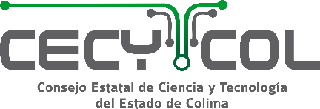

UK–Mexico Newton Fund: Improving Mexican Crop Resilience to Abiotic Stress

Applicant List
Please provide the names, full affiliations of all principal and co-investigators. Please indicate the lead investigator from each country in bold font.

Country and Funder | Position | Name | Organisation | Department/Division | E-mail (lead investigator from each country only)

Please note: All documents submitted to BBSRC will be securely shared with the relevant Mexican funding agency to facilitate peer review (eligibility checks and reviewer identification).

